Heidi’s Gluten-Free Pantry
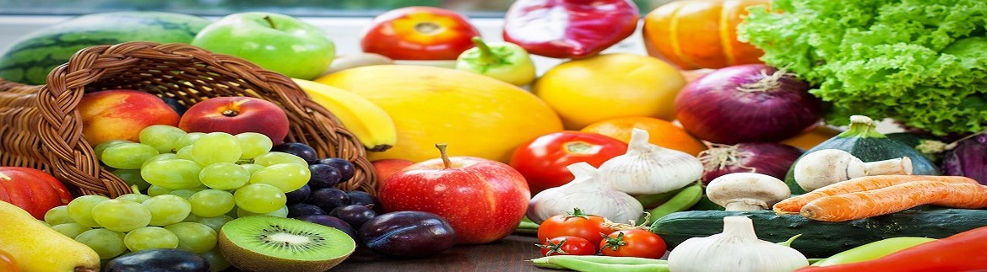
Heavenly Baking & Cooking

